
Khurana & Khurana, Advocates and IP Attorneys
E- 13, UPSIDC Site-IV, Behind Grand Venice, Kasna Road, Greater Noida - 201308, India
Phone: +91.120. 2399010/4296878, Fax: 2399011Website: www.khuranaandkhurana.com
Email: info@khuranaandkhuraana.com
Offices: Noida (New Delhi). Pune . Mumbai . Bangalore. Hyderabad. Indore . Chennai . Jalandhar

To, September 12th, 2020
The Controller of Patents,
The Patent Office

KIND ATTN: SHRI. VIKAS GUPTA
CONTROLLER OF PATENTS

Dear Sir,
Re: Patent Application No. 202021023694 Filed on: 05/06/2020
Applicant(s):
1. Archana Ghotkar
2. Shriniwas Nayak
3. Hrushabh Hirudkar
4. Anuj Kanetkar
5. Sheetal Sonawane
Title: A SYSTEM FOR RECOMMENDING A RELEVANT QUERY USING A STATISTICAL METHOD
Letter No: Ref. No/Application No/ 202021023694 Dated: 06/08/2020

Dear Sir,

This is in reference to the examination report dated 06/08/2020 against Indian Patent Application 202021023694, referred hereafter as present application/invention.
----------------------------------------------------------------------------------------------------------------
AMENDMENTS TO CLAIMS
- In view of the objections related to Part-II (points 1-7), put forth in the examination report, however, without admitting to the propriety of the rejections/objections, the Applicant respectfully submits that the pending claims (on file) have been suitably amended to make them clear, concise, and also submits the revised claims in the prescribed manner which are now in condition of allowance. Revisions in claims are as under:
- Original claims 1 and 10 on file are now amended to include a characterizing portion. The original claims 1 and 10 on file are also amended to delete the term “at least one” in order to overcome objection in the examination report. The independent claim 1 has also been amended to include technical features from original claim 4. The amendment is also supported by para [0039] of the original specification.
- Original claim 9 and dependent claim 4 have been deleted.
- Dependent claims 2-8 have been renumbered and their dependencies have been adjusted wherever applicable.
- Applicant submits that all changes made to the pending claims are within the scope of the original claims.
- Applicant submits that no new matter has been added to any of the pending claims.
- It is submitted that all the amendments to the claims are directly and unambiguously derivable from the application as originally filed, and therefore meet the requirements of the Patents Act, 1970.
- In order to facilitate review of the amendments, a compared version of the amended claims 1-8 having the amendments compared to the original version of claims 1-10 are enclosed along with this response. Marked up as well as clean copies of the amended claims are enclosed with this response.
- All amendments are made without prejudice or disclaimer of subject matter that has been deleted at this stage. The Applicant reserves the right to reintroduce any deleted matter in this application or in a subsequent divisional application.
----------------------------------------------------------------------------------------------------------------

RESPONSE TO OBJECTIONS

PART-II: DETAILED TECHNICAL REPORT
[(1)-(2)] NOVELTY AND INVENTIVE STEP:
With regards to the objection pertaining Novelty and Inventive Step on claims 1-10 in view of the following documents that have been cited:
D1: US 20120265779A1, and
D2: Pawan Sharma et. al, “Finding Similar Patents Through Semantic Query Expansion”
the learned Examiner through the examination report observed that the claims lack novelty and inventive step and are not allowable u/s 2(1)(j) and 2(1)(ja) of the Patent Act, 1970.

The Applicant respectfully submits that the pending claims are NOVEL, INVENTIVE & NON-OBVIOUS in view of the cited documents and requests the Examiner to kindly consider the set of claims presented in the instant response and withdraw the objection thereby. Presented below are arguments in support of Novelty and Inventive Step of the present invention.
----------------------------------------------------------------------------------------------------------------
The Applicant would like to highlight that notwithstanding other aspects of differences in the features of the present invention in view of the cited references, the following inventive technical features of the amended claim 1 and claim 10 (renumbered as claim 8) are not at all disclosed/taught in any cited document D1 or D2, either alone or in combination:
- device/method that compute, in response to the input query, an output recommending at least one relevant query selected from one or more queries in a dataset, wherein the output is computed based on a similarity between the input query and each of the one or more queries at an evaluated optimum value of a weight factor (L) to recommend the at least one relevant query to the user (102) in response to the input query;
- wherein the optimum value of the weight factor (L) is evaluated, based on a least difference between the respective rank and the first rank, at a server that receives a first query and a dataset including one or more queries and computes a first rank for each of the queries with respect to the first query, wherein each of the queries is associated with a respective rank assigned with respect to the first query and wherein the first rank is calculated based on similarity between the first query and each of the queries at a pre-defined value of a weight factor (L), the weight factor (L) indicates an extent of a semantic similarity and a syntactic similarity between the first query and each of the queries.
The Applicant submits that none of the cited documents even mention recommendation of a relevant query based on an evaluated optimum value of a weight factor (L). This weight factor is evaluated by taking into account a combination of both semantic and syntactic similarity which is the core novel and inventive aspect of the present invention. The significance of taking both semantic and syntactic similarity in account leads to recommendation of most relevant query that is not possible to obtain by just considering semantic similarity, as done by the cited documents D1-D2, wherein sematic similarity only corresponds to similar meaning words. Further, relying only on syntactic similarity may also not be appropriate as syntactic similarity involves use of same words without even considering the meaning being conveyed, and thus syntactic similarity, when used alone, may not be able to reject dissimilar questions. The Applicant submits that the present invention is trying to address this very issue related to the isolated use/implementation of syntactic and semantic similarity, and hence the Applicant humbly, but firmly submits that the cited documents are not even addressing this issue and neither providing a solution that involves implementation of weight factor that includes combination of semantic and syntactic similarity. Rather, in view of the problem being addressed by the present invention, the cited documents qualify only as a conventional means in the art that use semantic analysis alone.
Further, as a general example (table/examples provided below are not cited from the specification and are being provided only for the sake of understanding), if one is trying to obtain a relevant query suggestion for “How to read string in Python”, a regular search may not be able to even recommend queries as will be clear in the table below.
Query | Using conventional techniques | Using device of the present invention
How to read string in Python? | - For loop Python  - Python print  - Python input integer | - What is Python?  - How to reverse String in Python?  - How to read string in Java?
However, using the present invention, a user may be able to not only get relevant query suggestions but also the nature of the suggestions can be very reliable as the system takes both semantic and syntactic similarity into account by use of a definite optimum weight factor (L).
The Applicant submits that the solution provided by the present invention is customizable as the individual datasets corresponding to various domains are used to evaluate optimum weight factor (L) that can give relevant output in a particular domain of query rather than in a generalized sense. The cited documents may have certain overlapping features such as use of semantic similarity but they fail to disclose/teach the core inventive concept of the present invention including the features of suggesting query at an optimum value of weight factor(L) that accounts for semantic and syntactic similarity as well as the manner in which the value of L is determined. These features in the present invention have been carefully evaluated and developed for a specific purpose of query recommendation, which is not just presented based on popular searches/frequently asked questions as usually done by conventional systems. Rather, the optimum weight factor (L) is evaluated beforehand in a learning phase, by assessing the least value of error (shown as blue colour highlighted portion) in the rank determination of the queries when done at various values of L (shown as green colour highlighted portion), based on which the best value of L is obtained by averaging out the L value for each of such queries in a particular domain. D1-D2 clearly lack disclosure of these features which will be further clearer from a detailed comparison with the cited documents as provided in the later section of the response.
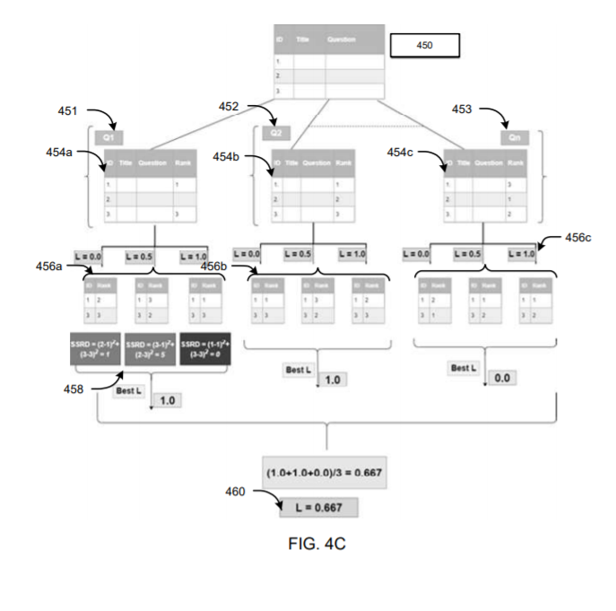
Figure 4C of present invention

The above arguments thus establish a clear basis for the technical advancement achieved by the present invention. In that respect, attention is drawn to the landmark Supreme Court judgment in Biswanath Prasad Radhey Shyam vs Hindustan Metal Industries where it is noted:
In order to be patentable, an improvement on something known before or a combination of different matters already known, should be something more than a mere workshop `improvement, and must independently satisfy the test of invention or an inventive step. It must produce a new result, or a new article or a better or cheaper article than before. The new subject matter must involve "invention" over what is old. Mere collocation of more than one, integers or things, not involving the exercise of any inventive faculty does not qualify for the grant of a patent.
As such, the instant invention clearly meets, not one but three of the above criteria laid down by the Supreme Court, wherein:
- it produces a new result, that is a new manner of obtaining relevant query suggestions that takes both semantic and syntactic similarity into account and suggests a query that can help a user in an effective way;
- it produces a new article, that is a device that can suggest relevant queries instantly based on an optimum weight factor that is pre-evaluated considering both semantic similarity (similar meaning) and syntactic similarity (same/similar terms);
- it produces a better article, that is a user-friendly device that can enable instant suggestion of similar and relevant queries, which is more reliable in nature.

And that alone should fulfill the criteria of non obviousness as per the test provided in the above-presented judgment, notwithstanding other submissions made hereinabove.
Furthermore, in view of the recited technical of the present invention that are undoubtedly nowhere present in the cited documents D1-D2, the Applicant believes that the inventiveness of the present invention is well established. However, to emphasize further on the other few overlapping aspects/features mapped in the examination report, the Applicant provides a more detailed comparison below with the cited prior art references:
Document D1 relates to a systems, methods for identifying query formulation suggestions in response to receiving a search query, wherein the system in D1 receives a portion of a search query and identifies query formulation suggestions by semantically analysing the search query [Please refer abstract of D1]. Thus, it is clearly visible that D1 only focusses on analysis based on semantic similarity (as shown in FIG, 27 below) and hence clearly does not take combination of semantic and syntactic similarity into account.
Figure 27 of D1
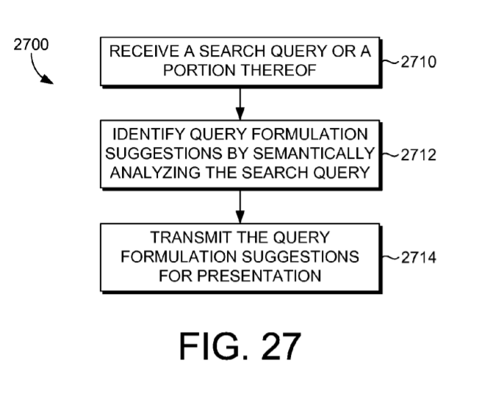

Further, the examination report cites several paragraphs from D1, out of which one paragraph mentions the term “weight factor”. The Applicant strongly asserts that the weight factor in D1 is nothing but weight corresponding to identified semantic query pattern. The cited paragraph [0050] defines the term weight as “In embodiments, weights or probabilities (that is, the likelihood of a particular semantic query pattern being a pattern that represents the true intent of a user) also may be determined by the semantic pattern identifying component 214.” This makes it crystal clear that the weights in D1 are only related to semantic analysis and hence does not anticipate/teach the weight factor having combination of semantic and syntactic analysis.
Not only this, but the manner in which D1 evaluates weight is totally different from the present invention. As will be clear from recitation of para [0050], “In embodiments, such weights may be determined based upon one or both of availability and interest. In terms of availability, the semantic pattern identifying component 214 may examine the data contained in the entity store 206 and estimate how frequently particular items or entities are likely to occur. For instance, in a commerce setting, the semantic pattern identifying component 214 may examine the data on product availability that is contained in the entity store 206 and estimate how frequently each entity is likely to be offered or available. The more frequently a particular entity will be offered or available, the higher the probability or weight assigned to that entity will be.”
The above recited paragraph clearly distinguishes the present invention in view of D1, as the weights are not determined by pre-evaluating optimum value of weight factor (shown in red colour highlighted portion) based on assessing the least value of error (shown as blue colour highlighted portion) in the rank determination of the queries when done at various values of weight factor (shown in green highlight). In fact, what the system in D1 does assigning the weight based on semantic pattern and the frequency/availability of products, wherein weighing based on popularity as taught by D1 may lead to problems/issues such as unreliable results which the present invention has successfully addressed.
Figure 4C of present invention

Hence, D1 is completely silent on the above recited aspects of amended claim 1 and claim 10 of the present invention and hence a person in the art would not anticipate/be taught on the core novel and inventive aspects of the present invention by reading document D1. Hence the claims 1 and 10 (renumbered as claim 8) are undoubtedly novel and inventive in view of D1.
Document D2 relates to system/method to find similar patents by expanding user query semantically, wherein the main purpose of D2 is to investigate how the patent retrieval system can be improved by using words which have same expression i.e. semantically similar [Please refer abstract]. First of all, D2 is nowhere related to obtaining suggestion/recommendation of query (which is the main objective of the present invention) and rather resembles a patent search engine, thus teaching away from the present invention. Further, the accuracy rate therein depends on the length of the query abstract, which becomes clearer upon referring to page 391 (section 3, Motivation) which recites “If an automated tool can be developed to ease the process of patent search, the grant procedure will be more responsive and quick. The hypothesis explored in this research is that by using semantic expansion of a query, we can provide high quality results and reduce the complex search process. Expansion technique semantically increases the number of words in a query which gives a better quality of retrieval result. The longer the query abstract, the higher the result accuracy rate.” Both of these aspects (patent search and length of query) are totally irrelevant and different from the present invention.
This would lead one to question if a person skilled in the art would even refer to D2 as a prior art as neither the problem being addressed nor the technical outcome in D2 are anywhere similar to the present invention. Further, the system in D2, as in the case of D1, is also focussed only on semantic analysis and not the combination of semantic and syntactic analysis, as disclosed by the amended claim 1 and claim 10 (renumbered as claim 8) of the present invention. Furthermore, D2 is silent on the evaluation of optimum value of weight factor based on assessing the least value of error in the rank determination of the queries when done at various values of weight factor (as shown in figure 4C of D2). Hence, the present invention is novel and inventive in view of D2.
In conclusion, the Applicant draws learned Examiner’s attention to IPAB decision in Enercon vs Aloys Wobben [ORA/08/2009/PT/CH, Order No. 123 of 2013], paragraph 43 which recites:
‘The mere existence in the prior arts, of each of the elements in the invention, will not ipso facto mean obviousness. For after all most inventions are built with prior known puzzle-pieces. There must be a coherent thread leading from the prior arts to the invention, the tracing of the thread must be an act which follows obviously. We must apply this reasoning to test if indeed it is obvious, or if it seems to us to be obvious to the person skilled in the art because of what we know now. If it is the latter, it is hindsight deduction and is not acceptable...’
Thereby, while the cited references mention some aspects of the present invention they do not in any way teach a person skilled in the art, the critical feature of the present invention explained above and particularly provided in presently amended claims, it would be erroneous to merely map components and decide obviousness without looking at the underlying technical features of the invention and only based on individual components through hindsight.
Thus, the technical advancement of the present invention over the systems disclosed in D1-D2, is clearly established. In addition, a person in the art may not have any motivation to combine D1 and D2 as the document D2 is related to patent searching and hence in no manner is a relevant document to the present invention. Even upon combining both D1 and D2, the present invention remains as not anticipated/not taught as the core novel and inventive concepts of the present invention recited at the outset (weight factor considering both semantic and syntactic approach and the manner in which weight factor is determined) are nowhere disclosed by D1 and D2, either alone or in combination. Hence, the amended claim 1 and claim 10 (renumbered as claim 8) are novel and inventive in view of documents D1 and D2. Also, by virtue of their dependencies on the novel and inventive independent claim 1, the respective dependent claims 2-8 (renumbered as 2-7) shall also be considered as Novel and Inventive.
Accordingly, the Applicant therefore requests the Learned Examiner to withdraw the present objections pertaining to Inventive step.

(3) NON-PATENTIBILITY u/s 3
1. In the examination report, the learned Examiner has objected that the claims 1-10 of the present invention falls within the scope of section 3(k) of The Patents Act, 1970, wherein a part of the objection states “1. Without prejudice to objection U/S 2(1) (j), the apparatus and system mentioned in claims 1-9 have no inventive constructional feature. It is comprised of conventional systems. The different conventional systems are processors, storage devices, servers, computer networks. These systems as such do not fall into the definition of a system. It is not evinced if said claims define any technical features or technical advance thereof, and apparently attract provisions U/S 3 (k) of the Act. Hence, said claims are not allowed.
2. Claim 10 recite various method steps without disclosing what apparatus/structural component carried out said steps. In absence any structural limitations, the subject matter of these claims is mere scheme or mental act and hence falls within scope of clause (m) of section (3) of the Patents Act, 1970 (as amended). Therefore invention claimed in said claim is not patentable.
3. As worded the method claimed in claim 10 appears to be a mere algorithm implemented through software. In other words the claimed method is a mere software application/product and hence not patentable u/s 3(K) of Patents Act, 1970.
The Applicant respectfully submits that the independent claims 1 and 10, do not fall within the scope of section 3(k) and clearly display technical advancement in view of the following discussion.
Firstly, the device/method of the present invention clearly solves the following technical problems/issues in the art:
- The methods in the art may present any similar query based on several ways such as a query for which top answer may be voted by a forum, in which the limitation may be that the suggested questions may not align closely with the query that the user had presented to the forum, and the majority of the suggested questions may be sometimes drastically different from the original query. Other search engines may suggest similar questions based on past search history which may not be relevant to the user and hence may not be reliable.
- Conventional systems or methods in the art use either a semantic approach that may propose a query based on similar meaning derived from the original query by the user, or a syntactic approach that may propose a query based on similar usage of words, however, the chances of obtaining a relevant query may be very less, as only syntactic approach may be bad at selection of similar queries and only semantic approach may be bad at rejecting dissimilar questions.
The present invention solves both the above issues in a simple and effective manner by recommending a relevant query to a user in response to an input query, which is based on a weight factor that uses both semantic and syntactic approach. Further, the device and method of the present invention may recommend a query in an instant and user-friendly manner.
Secondly, the device/method of the present invention clearly involves the following technical features and technical advancement:
- recommending a query suggestion by computing an output based on a similarity between the input query and each of the one or more queries at an evaluated optimum value of a weight factor (L) to recommend the at least one relevant query to the user (102) in response to the input query;
- evaluating the optimum value of the weight factor (L), based on a least difference between the respective rank and the first rank, at a server that receives a first query and a dataset including one or more queries and computes a first rank for each of the queries with respect to the first query, wherein each of the queries is associated with a respective rank assigned with respect to the first query and wherein the first rank is calculated based on similarity between the first query and each of the queries at a pre-defined value of a weight factor (L), the weight factor (L) indicates an extent of a semantic similarity and a syntactic similarity between the first query and each of the queries.
Thirdly, the device/method of the present invention clearly involves the following components that indicate the device involving tangible components:
- Computing device (104) including one or more processors
- Centralized server (112)
Lastly, the device/method of the present invention clearly involves the following tangible activities that go beyond “normal” interaction between a computer program and hardware:
- The interaction between computing device (104) and server (112) (as shown in figure 1 below) is nothing but transmission of data packets, which of course is not within the purview of a software and is definitely beyond “normal” interaction between a computer program and hardware.
- Displaying of output on the computing device (104)
The most evident indication of this aspect is clear from the steps like evaluation of weight factor at the server and the computing of queries at the computing device, which cannot be executed by an algorithm or software per se and hence requires physical hardware/architecture as well as transmission of data packets.
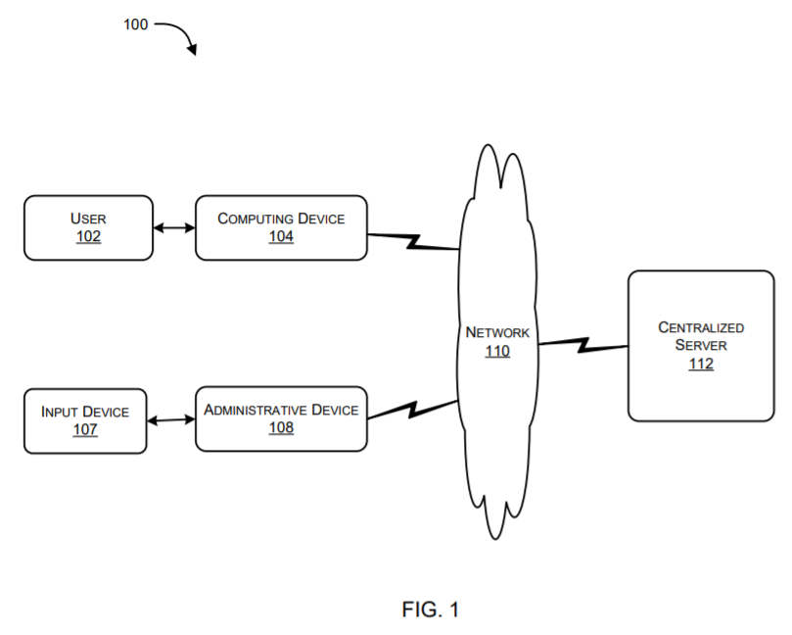
Figure 1 of present invention

In view of the above discussion, the Applicant believes that the present invention displays presence of clear technical features and technical advancement as well as involves features/activities beyond “normal” interaction between a computer program and hardware. The use of the device/method of the present invention can lead to not only to obtaining relevant query suggestions but also such output has been obtained after careful evaluation of the weight factor that takes both semantic and syntactic approaches into account so that the output queries are not only relevant but also accurate and reliable as the best value of weight factor is decided based on least error value in query rank. No existing conventional systems and methods have been able to achieve these objectives as they focus on either semantic or syntactic approach. Further, no existing systems dynamically obtains the most suitable combination of the above-mentioned approaches (syntactic and semantic) by evaluation of an appropriate weight factor. In addition, the device functions in real time and does not need any feedback from the user to determine output which other approaches may require and the device dynamically finds an optimal combination of syntactic and semantic approaches for any domain as per requirement. Looking from this perspective, the device and method of the present invention are way advanced than their conventional counterparts. Further, in a general sense, the Applicant would like to recite some applications wherein the device and method of the present invention may be useful such as in virtual teaching, virtual sales/marketing, holistic learning, information retrieval application, chat bot applications and the like.
Therefore, the device and method is undoubtedly a game-changing and revolutionary implementation that would hugely benefit user community. The hardware components used in the system of the present invention lead to a significant technical effect or outcome in comparison to existing systems in the art, which do not even address issues that are resolved by the present invention and hence the claims of the present invention are definitely not within scope of section 3(k) of the Act.
Further, the Applicant submits that the invention as claimed in amended claim 1 cannot be not categorized as computer program per se or under Section 3(k) of the Act, since the revised CRI Guidelines of June 2017 states that an invention should be judged from the substance of the claim as a whole (Refer 4.5, paragraph 3), and that it also needs to be assessed whether the invention has practical application to determine whether it should be excluded from patentability under Section 3(k). Furthermore, as stated in the revised guidelines in context of the views expressed by the Joint Parliamentary Committee, the intention of the legislature is not to reject inventions related to computer program for grant of patent if they satisfy the requirement of inventions under the Act (Refer 4.5.4).
The Applicant submits that, in view of the fact that technical advancement has been clearly established from the previously presented paragraphs, there is no doubt that the system of the present invention exhibits a technical effect and hence is not just a program running on a hardware.
This further clearly complies with the official requirements set forth by the Hon’ble Delhi High Court in Ericsson vs. Intex (order in CS(OS) No.1045/ 2014 dated March 13, 2015), which holds that, ‘… any invention which has a technical contribution or has a technical effect and is not merely a computer program per se as alleged by the defendant and the same is patentable.’ Further, similar such views were held in Ferid Allani v. Union of India, 2019 SCC OnLine Del 11867, decided on 12-12-2019, the High Court observed that “Whether they are cars and other automobiles, microwave ovens, washing machines, refrigerators, they all have some sort of computer programs in-built in them. Thus, the effect that such programs produce including in digital and electronic products is crucial in determining the test of patentability.............Patent applications in these fields would have to be examined to see if they result in a `technical contribution...........Across the world, patent offices have tested patent applications in this field of innovation, on the fulcrum of `technical effect‟ and „technical contribution”. Similar views were also held in a recent ex parte grant order of the same case (order in OA/17/2020/PT/DEL dated July 20, 2020).
Further, as stated in the Revised Guidelines for Examination of Computer Related Inventions (CRIs) (2017), the meaning of the term algorithm is construed as per the definition of the Oxford Advanced Learners Dictionary as ‟a set of rules that must be followed when solving a particular problem”, which is further defined for claims directed to algorithm recited as “Algorithms in all forms including but not limited to, a set of rules or procedures or any sequence of steps or any method expressed by way of a finite list of defined instructions, whether for solving a problem or otherwise, and whether employing a logical, arithmetical or computational method, recursive or otherwise, are excluded from patentability” (please refer 4.5.3 Claims directed as “Algorithm”).
Further, the technical steps of claim 10 are not just “a set of rules expressed by way of a finite list of defined instructions” but require evaluation of the optimum value of weight factor at the server which is further used by the computing device to compute the relevant suggestions thus indicating clear interaction between the computing device and the server (exchange of data packets via network as shown in figure 1 of the present invention). In addition to these aspects, the steps like receiving an input query from the user is also a tangible step and way beyond the scope of an algorithm. Any computer program per se (involving execution of readable instructions with the help of algorithm) shall not be able to accomplish all the steps by itself such as those executed by the device of the present invention, as such steps would require interaction between the computing device and the server that nowhere is within the scope of finite list of defined instructions and is devoid of any logical, arithmetic and computational method.
Further, the features of amended claim 10 cannot be categorized as mental act u/s 3 (m) as the claim 10 involves pure technical steps which include evaluation of the optimum value of weight factor at the server which is further used by the computing device to compute the relevant suggestions thus indicating clear interaction between the computing device and the server (exchange of data packets via network as shown in figure 1 of the present invention). In addition to these aspects, the steps like receiving an input query from the user is also a tangible step and way beyond the scope of just a mental act. Hence, these technical features definitely utilize apparatus/structure component such as computing device and server and hence the objection that “Claim 10 recite various method steps without disclosing what apparatus/structural component carried out said steps” is incorrect. The mentioned technical features lead to a technical outcome that enable obtaining very accurate, precise and relevant query suggestions in an instant and a user-friendly way, wherein the involvement of structural features and the resulting outcome makes the claim 10 of the present invention to not fall within the purview of mental act or section 3 (m).
In view of the above arguments, it is clear that the amended claim 1 of the present invention is not a computer program per se and hence the amended claim 1 does not fall within the scope of Section 3(k) of the Act. In view of the above arguments, it is also clear that the amended claim 10 of the present invention is not a mere algorithm implemented through software and not a mere software application/product as well as not a mental act and hence the amended claim 1 does not fall within the scope of Section 3(k) and section 3(m) of the Act.
Accordingly, the Applicant therefore requests the Learned Examiner to withdraw the present objections pertaining to Non-Patentability.

(5) SCOPE:
In the examination report, the learned Examiner has cited
1. In view of the plurality of the independent set of claims, the nature and scope of the alleged invention are not clearly understood. The subject matter for which protection is sought may be different to that defined by the claims, thereby resulting in a lack of clarity of the claims when the description is used to interpret the claims. The claims should be re-drafted to make them sufficiently definitive and Inventive features should be brought out clearly and clearly define the scope of the invention, in accordance with section 10 (4) (c) of The Patents Act 1970 as amended by the Patents (Amendment) Act 2005. During revision and re-drafting, care should be taken not to add any subject matter, which extends beyond the scope of the application as originally filed here your attention is also drawn towards section 59 of the patent act.
The Applicant submits that the original independent claim 1 on file has been suitably amended to include the technical features of the original claim 4. In view of this amendment, the Applicant believes that the amended claim 1 clearly describes definitive and inventive features and hence the present objection is sufficiently addressed in view of the amendments. Hence, the Applicant requests the Examiner to withdraw the present objection.

2. Although claims 1(device claim) and 9 (system claim) have been drafted as separate independent claims, they appear to relate effectively to the same subject-matter and to differ from each other only with regard to the definition of the subject-matter for which protection is sought. Hence, they do not provide alternative solutions to a common particular problem which could not appropriately have been covered by a single claim. Consequently, claims 1 and 9 are not allowable.
The Applicant hereby submits that in order to expedite the prosecution, the system claim 9 on file has been deleted. Hence, the Applicant requests the Examiner to withdraw the present objection.
(6) CLARITY AND CONCISENESS:
In the examination report, the learned Examiner has cited
1. The vague and imprecise term ‘spirit’ in the description in the paragraphs [0023] and [0027] implies that the subject-matter for which protection is sought may be different to that defined by the claims, thereby resulting in a lack of clarity of the claims when the description is used to interpret the claims. Such statement should therefore be amended to remove this inconsistency
The Applicant submits that the term “spirit” in paragraphs [0023] and [0027] are part of standard disclaimers. However, in order to address the objection effectively, the specification has been amended to delete the term “spirit” therein. The Applicant humbly submits that this amendment is solely done to address the present objection and hence cannot be considered as voluntary amendments. In view of the amendment, the Applicant requests the Examiner to withdraw the present objection.
2. Principal claim should sufficiently define, characterize and clearly bring out the inventive step.
The Applicant has amended the independent claims 1 and 10 (renumbered as claim 8) effectively to include the characterizing portion as well as have added features of claim 4 to independent claim 1 to sufficiently define, characterize and clearly bring out the inventive step. In view of the amendments, the Applicant believes that the objection is sufficiently addressed and hence requests the Examiner to withdraw the present objection.
3. The "at least one" terms used in various claims have no well-recognized meaning and leaves the reader in doubt as to the meaning of the technical features to which it refers, thereby rendering the definition of the subject-matter of said claims unclear.
The Applicant has amended claims 1 and 10 (renumbered as claim 8) to effectively delete the term “at least one” to effectively address the above objection. Thus, in view of the amendments, the Applicant requests the Examiner to withdraw the present objection.

(7) DEFINITIVENESS:
In the examination report, the learned Examiner has cited
1. The complete specification shall fully and particularly describe the invention and its operation or use and the method by which it is to be performed and disclose the best method of performing the invention wrt the illustrations provided. A detailed description of all illustrations shall be provided which in turn provide a clear support for the claims.
The Applicant respectfully traverses the present objection in view of the sufficient operation explained, especially in view of the figures 3 and 4A-4D as well as the description corresponding to these figures in paragraphs [0050] to [0057] of the specification on file. Further, the independent claim 1 has been amended to include features/limitations of claim 4 to enhance the definitiveness of the independent claim 1. In view of this, the Applicant believes that the objection is sufficiently addressed and hence requests the Examiner to withdraw the present objection.
2. Claims do not sufficiently define the invention. The inventive features should be incorporated in the principal claim and the corresponding subsidiary claims shall be made dependent upon the principal claim so as to make the invention sufficiently definitive.
The Applicant has amended the independent claims 1 and 10 effectively to include the characterizing portion as well as added features of claim 4 to independent claim 1 to sufficiently define the claims. Further, the dependencies have been adjusted to make the claims 2-8 (renumbered as 2-7) dependent on claim 1. In view of the amendments, the Applicant requests the Examiner to withdraw the present objection.

PART-III: FORMAL REQUIREMENTS

1. Statement & Under Taking (Form 3 Details)
Updated annexure to form 3 should be filed.
The Applicant submits that any PCT or convention application corresponding to the present application has not been filed. In view of this, there are no updates since the submission of form 3 dated 05-06-2020. Hence, the Applicant requests the Examiner to consider the earlier uploaded form-3 on record and to withdraw the present objection.
2. Power of Attorney
A fresh power of authority or an attested copy of the GPA (clearly indicating the present patent application number) should be submitted.
To be verified and included.
3. Other Deficiencies
1.If any amendment is necessitated in the complete specification then it is required to clearly identify (submission of marked copy) the amendments carried out and to indicate the portion (page no and line no) of the complete specification as filed on which these amendments are based on. Further the pages wherever amendments are carried out need to be freshly typed on white pages and to be filed in duplicate
The Applicant submits that no amendments are made to the specification except the deletion of term “spirit” in paragraphs [0023] and [0027] of the specification (to address objection in FER), for which marked copy is provided. The Applicant humbly submits that this amendment is solely done to address the objection. In view of this, the Applicant requests the Examiner to take the marked copy of specification on record.
2. Details regarding the search and/or examination report including claims of the application allowed, as referred to in Rule 12(3) of the Patent Rules in respect of same or substantially the same invention filed in all countries outside India, along with appropriate translation where applicable, should be submitted within a period of Six months from the date of receipt of this communication as provided under section 8(2) of the Indian Patents Act.
The Applicant submits that any PCT or convention application corresponding to the present application has not been filed. In view of this, there are no search and/or examination reports corresponding to any application filed outside India. Hence, the objection is rendered moot.
3. Details regarding application for Patents which may be filed outside India from time to time for the same or substantially the same invention should be furnished within Six months from the date of filing of the said application under clause(b) of subsection (1) of section 8 and rule 12(1) of Indian Patent Act
The Applicant submits that any PCT or convention application has not been filed corresponding to this application. In view of this, there are no details corresponding to any application filed outside India. Hence, the objection is rendered moot.
4. In case the applicant decides to amend the claims subsequent to this report, the same shall be drafted afresh to include the technical advancement over the prior art as required u/s 2(1)j of the Patent’s Act. Please indicate in the response communication the support for the claims in the original specification, as required u/s 10(4) of the Act.
The Applicant has amended the independent claims 1 to include features of claim 4 as well as included the characterizing portion to sufficiently highlight the technical advancement. The Applicant submits that the claim amendments are based on the original claims itself which is well supported in summary and description. Hence in view of this, the Applicant requests the Examiner to withdraw the present objection.
5. Application number in form 3 and form 5 is not mentioned. Fresh Form 3 and Form 5 should be submitted.
The Applicant has now submitted fresh form 3 and form 5 with application number included therein. Therefore, the Applicant requests the Examiner to withdraw the present objection.
Conclusion:
Applicant submits amendments and remarks in view of the examination report. Applicant believes to have overcome all objections mentioned in the examination report, and believes that the application is now in condition for allowance. Applicant respectfully requests that a notice of allowance be issued in this case. In case of any query, the Examiner is requested to call the undersigned. We request the Examiner to kindly offer us an opportunity of being heard under Section 14 of the Indian Patent Law before taking a decision adverse to the Applicant’s interest.

Yours faithfully,

Tarun Khurana (INPA-1325)
Khurana & Khurana, Advocates & IP Attorneys
Applicant’s Agent

Enclosures:
- Marked up Copy of Amended Claims
- Clean Copy of Amended Claims
- Marked copy of Specification
- Form-3 and Form-5

